**SECTION A**

1. Name the force that causes wearing and reducing of shoe soles after a long time use.

.............................................................................................................................

2. What advice can you give to a farmer whose metallic garden tools develop a reddish brown colour every night?

.............................................................................................................................

3. Which method of heat transfer allows circulation of air in a living house?

.............................................................................................................................

4. Why does sand soil retain water for a short time?

.............................................................................................................................

5. Which part of an ordinary pit latrine lets out bad smell from the pit?

.............................................................................................................................

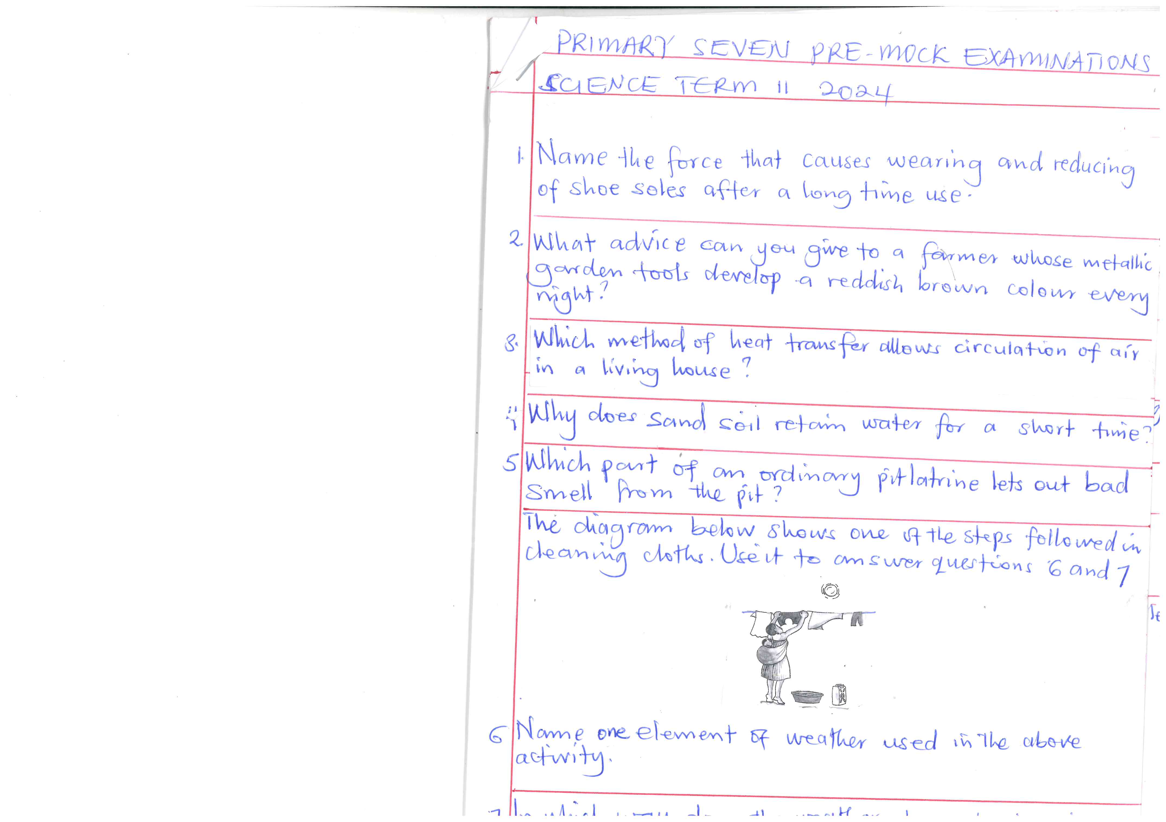 **The diagram below shows one of the steps followed in cleaning cloths. Use it to answer questions 6 and 7.**

6. Name one element of weather used in the above activity.

.............................................................................................................................

7. In which way does the weather element given in question (6) above help in drying of the cloths?

.............................................................................................................................

8. Why are people advised to include roughages in their diet?

.............................................................................................................................

9. Give one characteristic of a duckbilled platypus.

.............................................................................................................................

10. What happens when light rays fall on a plane mirror?

.............................................................................................................................

11. State one way in which mothers can increase milk production in their breasts during lactation period.

.............................................................................................................................

12. Name one example of animal fibre.

.............................................................................................................................

13. What is formed when wood is half burnt with less oxygen supply?

.............................................................................................................................

14. Name the requirement for sound movement missing in a vacuum.

.............................................................................................................................

15. Identify any one component of blood.

.............................................................................................................................

16. Why do egret birds commonly keep and move around with grazing cattle in the community?

.............................................................................................................................

**The diagram below shows two pairs of male and female animals in each. Undergoing an activity in reproduction. Use it to answer questions 17 and 18.**

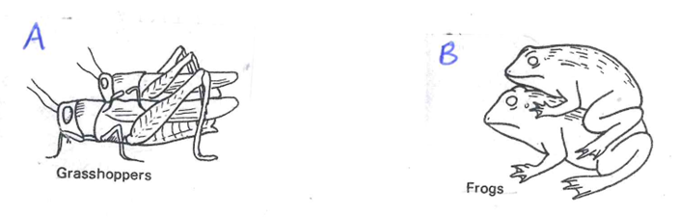

17. State the type of fertilization that results from the activity in diagram A above.

.............................................................................................................................

18. Apart from group B above, give any other group of vertebrates with the same type of fertilization.

.............................................................................................................................

19. Name one first aid tool for fractures.

.............................................................................................................................

20. State one process that takes place in kidneys.

.............................................................................................................................

21. Give the main element of PHC promoted by cooks at school.

.............................................................................................................................

22. Mention one example of health concern in your community.

.............................................................................................................................

23. Mention one way in which machines simplify work.

.............................................................................................................................

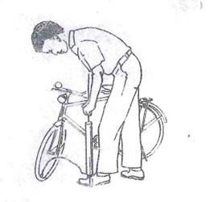**The diagram below shows a property of air . Use it to answer question 24.**

24. State the property of air illustration in the above diagram.

.............................................................................................................................

25. What is immunity?

.............................................................................................................................

.............................................................................................................................

26. Give any one example of a poultry bad habit.

.............................................................................................................................

27. Cite one example of properties of magnets.

.............................................................................................................................

28. Why are electric wires loosely connected on poles?

.............................................................................................................................

29. Name the acid found in the stomach during digestion of food.

.............................................................................................................................

30. To which class of lever does a wheel barrow belong?

.............................................................................................................................

31. How are air sacs adapted to their function?

.............................................................................................................................

32. Why do crop farmers carry out hardening off in a nursery bed?

.............................................................................................................................

33. Give one bacterial tick bone disease in live stock farming.

.............................................................................................................................

34. In which way is the propagation of pines similar to that of beans?

.............................................................................................................................

35. How is the left side of the heart adapted to its function?

.............................................................................................................................

**The table below shows different classes of food use it to answer question 36.**

|  |  |  |  |
| --- | --- | --- | --- |
| **A** | **B** | **C** | **D** |
| mangoes  pineapples  oranges  apples | cassava  maize  yams  honey | fish  beans  sweet potatoes  eggs | cabbage  nakati  dodo  bugga |

36. Which class of food in the table above has the odd man out?

.............................................................................................................................

37. How best can school girls safeguard themselves against early pregnancies?

.............................................................................................................................

38. What is the difference between a resource and an energy resource?

.............................................................................................................................

.............................................................................................................................

39. Sate the effect of heat on matter that can be determined using a thermometer.

.............................................................................................................................

40. How do dehydrated sports men and women rehydrate their bodies after and during the match?

.............................................................................................................................

**SECTION B**

41a) What are essential drugs?

.............................................................................................................................

.............................................................................................................................

b) Give any two examples of essential drugs.

(i) ...........................................................................................................................

(ii) ............................................................................................................................

c) State any one quality of essential drugs.

.............................................................................................................................

42. Given a group of organisms below, study them carefully and answer questions that follow.

Grass cow tiger bacteria

a) By the help of a ruler and a pen, draw arrows to complete the above food chain.

b) From the list above, name the;

(i) producer

.............................................................................................................................

(ii) primary consumer

.............................................................................................................................

c) What would happen to a tiger if all cows were killed?

.............................................................................................................................

43a) What are food taboos?

.............................................................................................................................

.............................................................................................................................

b) Give two examples of food taboos.

(i) ...........................................................................................................................

(ii) ............................................................................................................................

c) State any one advantage of food taboos in a community.

.............................................................................................................................

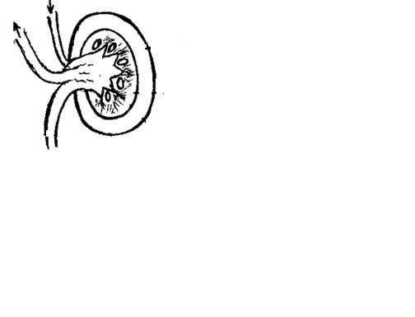**44. The diagram below shows a cross section through a kidney. Use it to answer questions that follow.**

**B**

**A**

pelvis **C**

**F**

a) Name the parts marked A and B.

(i) A ......................................................................................................................

(ii) B .....................................................................................................................

b) Give one way of caring for our body organs.

.............................................................................................................................

c) State one bad habit that affects the proper functioning of our body organs.

.............................................................................................................................

**45. Match list A with list B correctly.**

**List A List B**

Skin Bile pigments

Lungs carbon dioxide

Kidney lactic acid

Liver uric acid

Nitrogen

(i) Skin ......................................................................................................................

(ii) lungs ....................................................................................................................

(iii) kidney .................................................................................................................

(iv) liver ....................................................................................................................

46. Use the diagram below of a pulley system and answer questions that follow.

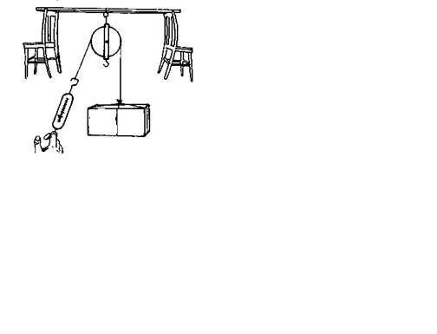

35kg f load

E

a) Name the type of pulley system drawn above.

.............................................................................................................................

b) Give any one use of the above pulley in our daily life.

.............................................................................................................................

c) Find the amount of effort needed to overcome the load shown in the above diagram. (2 marks)

47a) Name any two fungal skin diseases in humans.

(i) ...........................................................................................................................

(ii) ............................................................................................................................

b) Give two ways in which trachoma and conjunctivitis are similar in the way of controlling their spread.

(i) ...........................................................................................................................

...........................................................................................................................

(ii) ............................................................................................................................

............................................................................................................................

**48. Rearrange the following sentences to make correct order of steps involved in cleaning clothes.**

1. Rinse the clothes and dry them before ironing.

2. Put the selected clothes in a basin with water and soap powder for some time.

3. Select and put dirty clothes together according to their colour and level of dirt.

4. Wash the clothes three times before rinsing them.

1. ...........................................................................................................................

2. ...........................................................................................................................

3. ..........................................................................................................................

4. ..........................................................................................................................

49a) Sate any one reason why termites are grouped under insects.

.............................................................................................................................

b) How are termites dangerous to a crop farmer?

.............................................................................................................................

c) Give any two uses of insects to people.

(i) ...........................................................................................................................

(ii) ............................................................................................................................

**50. The diagram below shows a light ray striking a reflecting surface. Use it to answer questions that follow.**

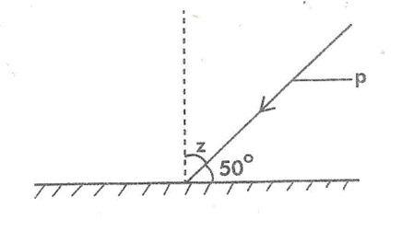

a) Name the ray marked P.

.............................................................................................................................

b) Complete the diagram above correctly.

.............................................................................................................................

c) How is reflection important to people?

.............................................................................................................................

d) Find the size of angle Z.

.............................................................................................................................

51a) How do we call the transfer of pollen grains from the anther to the stigma of a flower?

.............................................................................................................................

b) Give any one characteristic of insect pollinated flowers.

.............................................................................................................................

c) What name is given to the reproductive part of a plant?

.............................................................................................................................

d) Apart from insects, give any other agents responsible for the transfer of pollen grains from the anthers to the stigma of a flower.

.............................................................................................................................

52a) To which group of tuber crops does each of the following crops belong?

(i) carrots ........................................................................................................

(ii) irish potato .....................................................................................................

b) Give one example of a tuber crop pest.

.............................................................................................................................

c) How does crop rotation control tuber crop pests in the garden?

.............................................................................................................................

53a) Where does respiration occur in the human body?

.............................................................................................................................

b) Name the two raw materials required for respiration.

(i) ...........................................................................................................................

(ii) ............................................................................................................................

c) Identify the main product of respiration in the body.

.............................................................................................................................

54a) Identify the type of change illustrated below.

1. Melting of ice

........................................................................................................................

1. Burning of a candle wick

........................................................................................................................

1. Development of breasts in girls

........................................................................................................................

b) What type of sex changes/characteristics in girls are those in (iii) above?

.............................................................................................................................

**55. Study the diagram below off a casualty and use it to answer questions that follow.**

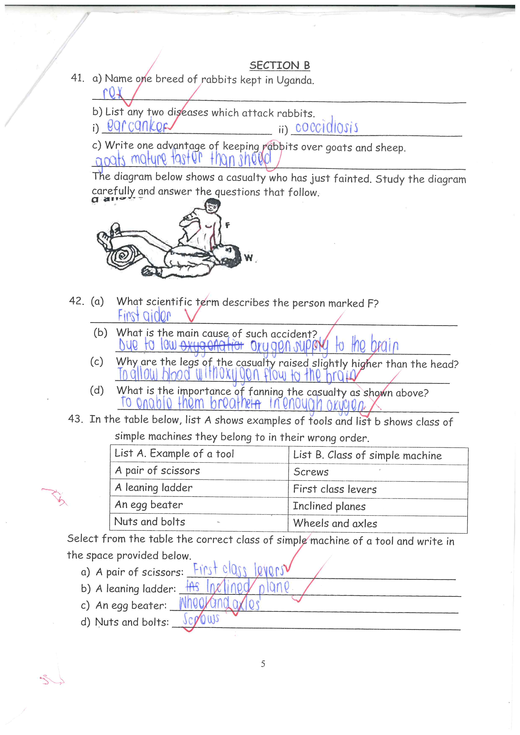

a) Name the accident that requires a victim to be positioned as shown in the diagram above.

.............................................................................................................................

b) What causes the above accident in human beings?

.............................................................................................................................

c) Why is the victim in the above diagram positioned with legs raised higher than the head?

.............................................................................................................................

d) Give a reason why the above victim is placed in an open place without bystanders.

.............................................................................................................................

**END**